Name ________________________________________________ Hr. _____________________

**Acceleration Notes**

**Acceleration** – the ________ at which ___________ is *changing* over time

Acceleration = change in velocity

time interval

If your speed increases by 1 m/s each second, then your acceleration is 1 m/s per second.

What is the acceleration for the steeper hill?

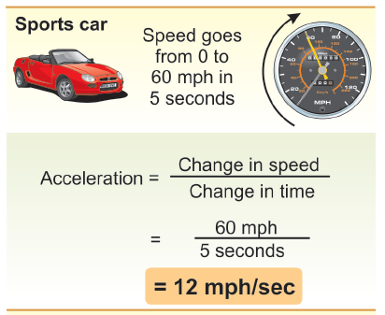

**Speed and ____________________ are ______ the same thing.**

**Acceleration is the ________ ____ _________ divided by the ___________ ___ _________.**



**A sailboat moves at 1 m/s. A strong wind increases its speed to 4 m/s in 3 s. Calculate acceleration.**

1. **Looking for:**
2. **Given:**
3. **Relationships:**
4. **Solution: a =**

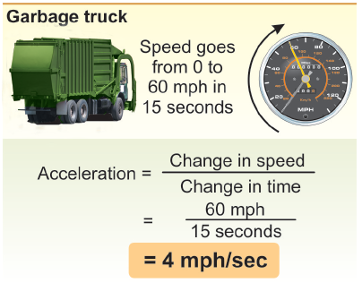

An ____________________ in m/s/s is often written as ___/____ (meters per second squared).

It is better to think about acceleration in units of __________ ____________ per ___________ (that is, meters per second *per second*).

Acceleration is __________ when velocity is ____________, for example when a car is speeding up.

Acceleration is _____________ when velocity is ________________, for example when a car is slowing down. Negative acceleration is called _____________________.

**Acceleration can be happening even if the ______________ of an object is ______ changing.**

**Remember, velocity consists of __________ *and* ______________. If the _____________ of motion is changing but the ___________ remains the same, the object is _______________.**

**Acceleration occurs whenever there is a change in _________, _____________, or _______.**



**Practice Problem:**

As a shuttle bus comes to a normal stop, it slows from 9.00m/s to 0.00m/s in 5.00s.

Find the average acceleration of the bus.

**a) A ball is dropped off a bridge**

* + Accelerating? Yes No
  + Speed? Increase / Decrease / Neither

**b) A man is running at a constant speed**

* + Accelerating? Yes No

Speed? Increase / Decrease / Neither

**Homework:**

**Read pg. 15-16;**

**Pg. 25 Review Questions 9-11;**

**Pg. 26 Probs. 27, 28**