Name __________________________________________ Hr ____________ Date _____________

**The Earth’s Surface**

**The Surface of Earth**

The features we see on Earth’s surface represent the ____________ between _______________ processesversus _____________________ processes. (building up vs. tearing down)



**Mountain Building**

Mountain-building is a major _____________________ process.

Mountains form in three main ways:

* + by ______________________ at ___________________ plate boundaries
  + by movement of chunks of land at __________________
  + by __________________ activity

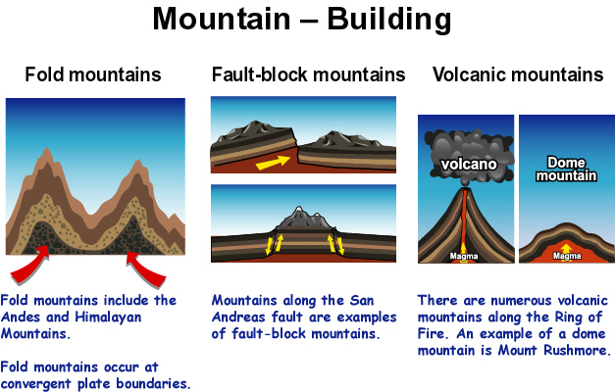

**Erosion**

Erosion (also known as _________________) is a major _________________ process.

Erosion describes the continuous ___________ & ____________ events that cause land & rock to wear down

The ________ of erosion is related to the ___________ and _____________ of the mountain—the steeper the mountain is, the faster it erodes because it is easier to push material down a steep slope than a gradual slope.

**Soil: Why should you Care?!**

* Soil is formed as a result of ________________. Soil is made of _______________ _______ and decayed plants and animals.
* Soil is rich in __________________(substances that provide _____________ or __________ ______________ for the survival and growth of a living things). It provides a good place for plants to anchor their roots and grow.

Through plants, the _____________ are passed on to ___!

**Soil Profiles**

* A soil profile is a cross-section that shows the different ______________ of ______ in the ground.
* It takes a ________ ____________ & a lot of ______________ for soil to have all the layers.
* Young soil does not have each of these layers.



**Glaciers**

* A glacier is a huge mass of ________ that can be many kilometers thick and thousands of kilometers wide.
* Glaciers at the north and south poles are a frozen form of about ___ _____________ of _____the water on Earth.
* Glaciers are formed from the accumulation of ________ over hundreds or thousands of years.

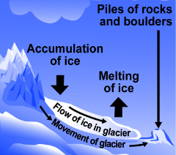

**Geologic Hazard Maps**

* Geologic hazard maps indicate the location of _____________ where ______________ occur, areas where ________________ are active, and where _______________, avalanches, ______________, or other natural hazards are possible.

**Urban Sprawl**

* The term ___________ _________________ refers to how living areas around a city “sprawl” as they grow instead of concentrate near facilities that serve the people of the community.
* Building roads changes the land.
* Roads and parking lots __________________ water from ____________ ____________ into the ground to replenish the water supply in aquifers.

**Practice:**

1. State whether the following processes that change the earth’s surface are constructive, destructive, both, or neither:

a. mountain building ____________________

b. erosion _______________________

c. glaciers __________________________

d. urban sprawl _______________________

2. Which type of mountain building occurs near a:

a. volcano ____________________ b. transform fault ________________

c. convergent tectonic plate ______________________