Name ____________________________________________ Hr ________

**Force Notes**

* A _________ is a push or pull, or an ________that has the ability to change motion.
* _________ can increase or decrease the speed of a moving object.
* Forces can also change the __________ in which an object is moving.

**How are forces created?**

__________ are created in many ways.

For example, your muscles create force when you swing a baseball bat; wind creates a force against an object; gravity.

**Units of force**

* The __________ is a unit of force commonly used in the United States.
* For smaller amounts, pounds are divided into __________ (oz.).
* There are ___ ounces in 1 pound.

When you measure weight in _________ on a postal scale, you are measuring the _________ of __________ acting on an object.

* Although we use pounds all the time in our everyday life, scientists prefer to measure forces in __________.
* The *newton* (N) is a ________ unit of ________.

One _________ is the __________ it takes to change the _______ of a 1 kilogram mass by 1 m/s per second.

**1 N = 1 kg m/s2**

One pound (lb) is about the _________ of 0.454 kg of ________.

One newton is the _________ it takes to change the speed of a 1 kg ________ by 1 m/s in 1 second.

Recall: change in _________ in an interval of time is _____________. So one newton is the ________ to ___________ 1 kilogram by 1m/s2.

* The newton (N) is a ___________ unit of force than the __________ (lb).
* One __________ of ________ equals 4.448 newton, so a 100 lb person weighs 444.8 newton.

**Force Vectors**



* We use arrows, called ___________, to represent the direction and magnitude of _________.
* The _________ of the arrow shows how _______ the force is (its magnitude).
* The direction that the arrow points shows the ________ in which the ________ is acting.

**How forces act**

* One way forces act is the result of __________ __________.
* A contact __________ is transmitted by matter directly ____________ other matter, such as wind acting to slow a parachute.
* The force of _________ between Earth and Moon appears to be what people once called “action-at-a-distance”.
* Today we know that the _________________ ___________ is carried from the Earth to the Moon by a __________  *_________.*

**Contact forces from ropes and springs**

* Ropes and springs are often used to make and apply ________.
* Ropes are used to transfer ________ or change their ____________.
* The pulling force carried by a rope is called ___________.
* Tension always acts along the direction of the rope.

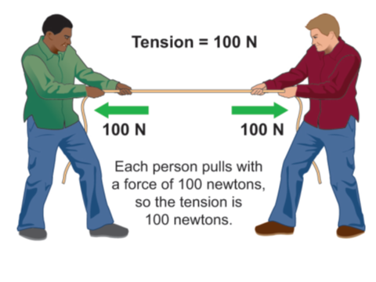 

**Which of these springs is designed to be stretched?**

**Which is designed to be compressed?**

**Spring Forces**

Springs are used to make or control ________.

The force from a spring always acts to return the spring to its _________ ________.

**Classify these forces as contact forces or the result of force fields:**



**Gravity**

* The force of acceleration of _________ acting on an object’s mass is called __________.
* At Earth’s surface, gravity exerts a force of _____ N on every kilogram of mass.

**Weight vs. Mass**

* *Weight and mass are ______ the same.*
* Mass is the *amount of _________* in an object measured in ____________ *(kg).*
* Weight is a __________measured in ____________(N*).*
* ___________ depends on mass and strength of acceleration of __________.

Weight depends on mass and gravity. A 10-kilogram rock has the same _____ no matter where it is in the universe. On Earth, the 10 kg rock *weighs* 98 N. On the moon, the same rock only _______16 N.



**The Weight Formula**

The weight equation can be rearranged into three forms to calculate __________, _________, or the strength of acceleration of gravity.

|  |  |  |
| --- | --- | --- |
| **Use:** | **To find:** | **When you know:** |
| **W = m x g** | **___________ (W)** | **mass (m) & acceleration of gravity (g)** |
| m = W  g | ________ (m) | weight (W) & acceleration of gravity (g) |
| **g = W**  **m** | **____________ of gravity (g)** | **weight (W) & mass (m)** |

**Calculate the weight of a 60-kilogram person on Earth, where g = 9.8 m/s2 and**

**on Mars, where g = 3.7 m/s2.**

1. **Looking for: _________** of person on both planets
2. **Given:** mass = 60 kg; g= 9.8 m/s2 on Earth; g = 3.7 m/s2 on Mars; we know that

1 N= 1 kg m/s2

1. **Relationships:** W = m x *g*
2. **Solution:**

**60 kg x 9.8 m/s2= 588 N on Earth**

**60 kg x 3.7 m/s2 = 222 N on Mars**

**Practice: Do the Practice Mass, Weight, and Gravity Practice problems!**