Name _____________________________________________ Hr _______

**Friction-Notes**

* *____________* is a force that resists the motion of objects or surfaces.
* Many kinds of friction exist.



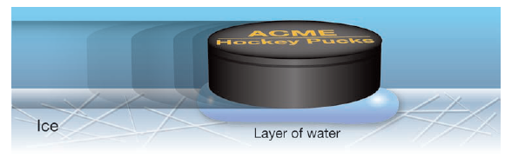

Friction depends on _______of the ________ in contact.

When the hockey puck slides on ice, a thin layer of water between the rubber and the ice allows the puck to slide easily.



**Identifying friction forces**

* Friction is a ________, measured in _________ just like any other force.
* *________ __________* keeps an object at ______from moving.
* *________ ________* is a force that resists the motion of an object __________ across a surface.

__________ depends on a material’s properties such as roughness, how clean the surfaces are, and other factors.

The greater the ________squeezing two surfaces together, the greater the _________ ___________.

**Reducing the force of friction**

* Unless a __________ is ___________ applied, friction will slow all motion to a _____ eventually.
* It is impossible to completely get rid of ___________, but it can be reduced.
* The _________ between a shaft (the long pole in the picture) and an outer part of a machine produces a lot of ________.
* Friction can be _________ by placing ball bearings between the shaft and the outer part.

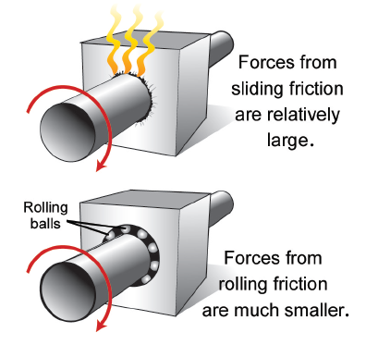

**Using Friction**

___________ is also important to anyone driving a car.

Grooved tire treads allow space for water to be channeled away from the road-tire contact point, allowing for __________ ____________ in wet conditions.

Shoes are designed to increase the __________ between their soles and the ground.

**Friction and energy**

___________ changes energy of motion into _______ energy.

__________ is always present in any machine with moving parts.

If the machine is small, or the forces are low, the amount of ______ produced by _________ may also be small.

**Practice:**

1. **In the picture below, explain why the bear fell. Use FRICTION to explain your answer.**

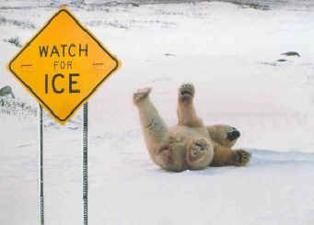

1. **How does surface roughness affect friction?**
2. **Discuss the relationship between the size and weight of an object and the amount of friction that is present**
3. **Sports such as soccer involve running, stopping, jumping, and kicking. Discuss how friction helps players.**
4. **Brianna is rowing a small boat across a pond. The air is calm; there is no wind blowing.** 
   1. **What type of fiction is resisting her motion?**
   2. **If two friends join her in the boat, will the friction force change? Why or why not?**