Name: _______________________________________ Hour: _________________ Date: _______________________

**Graphing Day 2**

**Notes:**

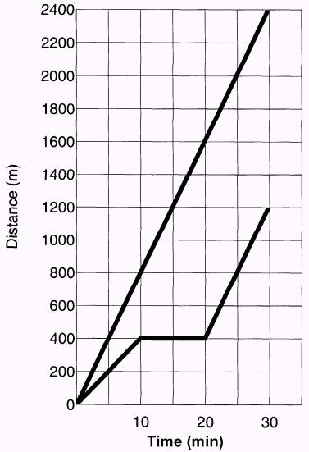

**Distance-Time Graph**

A

B

Looking at the graph to the side, answer the following questions:

* 1. What does the slope of this graph represent? ______________
  2. What does a steeper slope mean? _______________________
  3. A straight line on a position vs. time graph represents what?

_________________________

* 1. A flat line (horizontal line) represents what? _______________
  2. What can be determined by a single point on the graph?

____________________________________

* 1. Who started out faster, A or B? ___________________
  2. Who had a constant speed, A or B? ____________________
  3. What was B doing from 10-20 seconds? ___________________
  4. Find the average speeds of both runner A and B.

A: ________________________

B: ________________________

**4 Steps on how to make a graph**

**Step 2:** Make a scale for each _______ by counting boxes to fit your largest value. Count by multiples of 1, 2, 5, or 10.

Scale must be _____________ – if one line on the x-axis is equal to 1 hr the rest of the lines on the x-axis must be equal to 1 hr.

To determine scale, first you must determine the __________ of your data

* _________is equal to your highest - lowest data value

Ex: If the __________ of your data is 0-23 your scale could be counting by 5s up to 25.

**Step 4:** Draw a smooth _________ that shows the __________ of the __________. Do not just connect the dots.

**Step 1:** Choose which will be the _______________and ________________ variables.

The dependent variable goes on the _______ and the independent variable goes on the __________.

**Step 3:** Plot each point by finding the

__________and drawing a line upward until you get to the right ___________.

**Practice:**





Dependent Variable:

Independent Variable:

**Now get some graph paper from the front table and create a graph for the following problems.**

1.Graph the data in the table which shows the distance bus 1 travels from 10:00 am to 11:30 am on Saturday morning.

|  |  |  |  |  |  |  |  |
| --- | --- | --- | --- | --- | --- | --- | --- |
| **Distance in km** | 0 | 10 | 20 | 30 | 40 | 50 | 60 |
| **Time** | 10.00am | 10.15am | 10.30am | 10.45am | 11.00am | 11.15am | 11.30am |

Using your graphed data, how far will the bus have traveled at 12:30 pm?

2. The following table gives the distance covered every 15 minutes by a person riding a bicycle. Graph this data.

|  |  |  |  |  |  |  |  |
| --- | --- | --- | --- | --- | --- | --- | --- |
| **Distance covered in km** | 0 | 5 | 15 | 20 | 25 | 30 | 35 |
| **Time in minutes** | 0 | 15 | 30 | 45 | 60 | 75 | 90 |

3. The following data shows the travel distance and time of a mouse traveling back to its nest to get its buddies after it discovered snack crumbs on the floor of the physical science classroom. Graph this data.

|  |  |
| --- | --- |
| Distance (m) | Time (s) |
| 0 | 0 |
| 1 | 13 |
| 2 | 25 |
| 3 | 40 |
| 4 | 51 |
| 5 | 66 |
| 6 | 78 |

4. Graph the following data which shows Usain Bolt’s World Record Olympic 2008 100 m dash.

Distance Time

(m) (s)

RT 0.165

10 1.85

20 2.87

30 3.78

40 4.65

50 5.50

60 6.32

70 7.14

80 7.96

90 8.79

100 9.69