**Name _______________________________________ Hr ________ Date_________________**

**Introduction to Understanding Earth**

* ______________ is the study of ___________ and ____________ that make up Earth and the processes that shape it.
* In 1666, ____________ ________ (1638-87) noticed that shark’s teeth resembled mysterious stones called “tonguestones” that were found in local rocks.
* Steno’s explanation helped him develop ideas about ______ _________ and ________ form.
* These ideas are used in a technique called ____________ ____________.
* Relative dating is a way to put events in the ___________ in which they ____________.
* The _________________ _______ of each layer of a rock formation can be determined by applying Steno’s idea called ____________________***.***
* A stack of newspapers illustrates superposition.
* ***______________________*** means that the ____________ ___________ of rock are __________ than the layers on the top.
* ***______________ _________________*** states that ______________ ______________ fall to the bottom of a basin, such as a riverbed, in response to gravity and result in *horizontal* layers.
* ***___________ ____________*** is the idea that layers of sediment ____________ in ______ ______________ when they form and before they become rock layers.
* The idea of ___________ **______________** states that layers of rock are continuous ___________ a geologic event like a river ______________ the layers or an earthquake them.
* Another important idea, developed by Scottish geologist James Hutton (1726-97), is that the **"______________ *______________ ________ __________*."**
* The idea of _________________ ________________ states that a vein of rock is __________ than the rock that surrounds a vein.
* 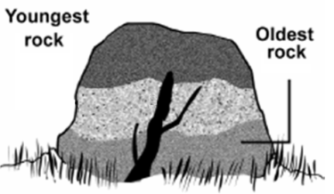 
* Sometimes rock pieces called ______________are contained in another rock.
* During the formation of a rock with inclusions, _______________ or ____________ ________ surrounded the inclusion and then solidified.
* So, the inclusions are __________ than the surrounding rock.
* Over geologic history, many animals and plants have lived and become __________**.**
* Their remains have become ___________.
* The idea of _____________ **_______________** states that __________ can be used to identify the relative age of layers of a rock formation.
* **William Thompson Kelvin (1824-1907), who also proposed the absolute temperature scale that came to be named after him, meticulously calculated Earth’s age at 10 million and 100 million years. His calculation was ______ _____________ because he did not realize that Earth has _____________ ___________ from the core and radioactive decay.**
* **Earth’s age was estimated by measuring the ___________ _________ of uranium to lead.**
* **With improved techniques and evidence from tree rings and glaciers, the age of Earth is estimated to be about _______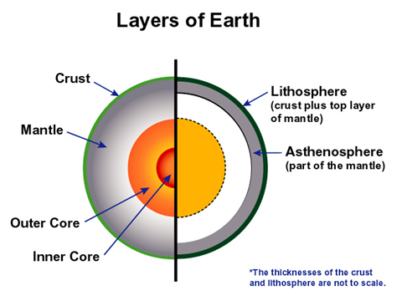___ ____________ ___________.**

**The Layers of the Earth**

* Earth’s surface is covered with a ___________crust.
* There are two kinds of crust:
  + ______________
  + _______________

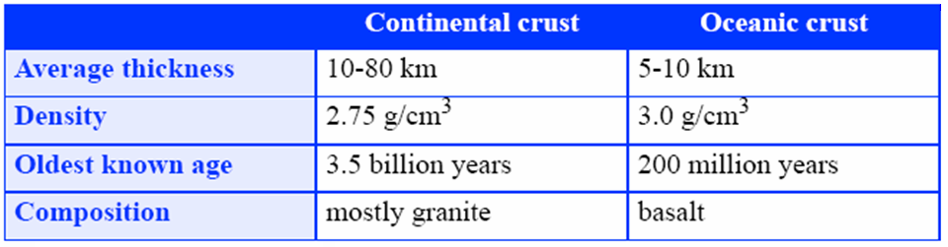

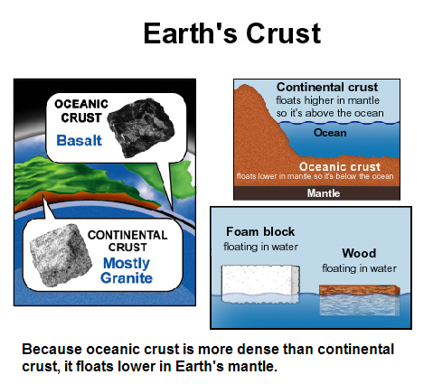

**Convection inside Earth**

* The rocky material of the ________ moves in very slow ____________ ____________.
* This movement is related to ___________ & _______________ ____________ in the mantle.
* Hot material is _________ dense and __________.
* Cold material is __________ and _________.

 