Name _______________________________________________________ Hr ____________

**MATH REVIEW CONTINUED-MEASUREMENT NOTES AND PRACTICE-KEY**

**Distance and Length**

measurement -

a quantity and a unit 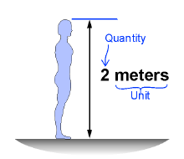

distance - 

-is a length

-the amount of space between two points

**Two Systems of Units**

Science problem solving requires both:

Metric system

English system

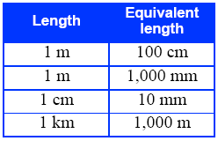 

**Units of Length**

* The common units of measurement in the English system are inches, feet, yards, and miles.
* These four length units are related to the meter.

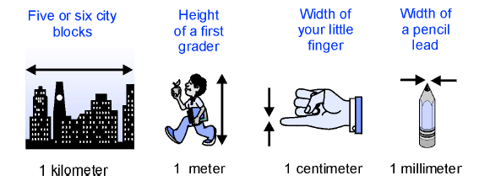

**Convert Units**

* **conversion factor -** 
  + **is the number by which you multiply or divide a quantity in one unit to express the quantity in a different unit.**

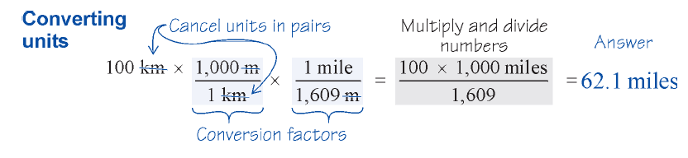

**Surface Area vs. Volume**

surface area - is the measurement of the extent of an object’s surface or area without including its thickness.

volume - is a measure of the space occupied by an object.

**Time: How do we measure and describe time?** 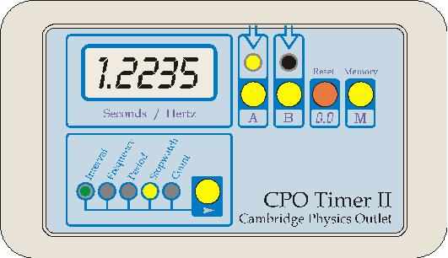

* Two ways to think about time:
  + What time is it?
    - 3 P.M. Eastern Time on April 21, 2013,
  + How much time has passed?
    - 3 hr: 44 min: 25 sec.
* A quantity of time is often called a time interval.

**Converting Mixed Units of Time**

1. You are asked for time in seconds.
2. You are given a time interval in mixed units.

1 hour = 3,600 sec

1 minute = 60 sec

1. Do the conversion:

1 hour = 3,600 sec

26 minutes = 26 × 60 = 1,560 sec

1. Add all the seconds:

t = 3,600 + 1,560 + 31.25 = 5,191.25 sec

**Time Units**



**Practice:**

**Practice:**

1. 3.45 millimeter = _______________ meter

2. 3.004 meters = _______________ centimeters

3. 112.3 meters = _______________ kilometers

4. 6567.09 millimeters = _______________ centimeters

5. 5.2 meters = _______________ millimeters

6. How many centimeters are in a kilometer? _______________ centimeters

7. 1,000 millimeters = ____________________ meters

8. 24.3 meters = ___________________________kilometers

9. 42 millimeters = ______________________________centimeters

10. 230 meters = ____________________________________ kilometers

11. How many seconds are in 2 hours 35 minutes and 15 seconds?

12. How many seconds are in 1 hour 20 minutes and 55 seconds?

13. How many minutes are in 193 seconds?

14. How many minutes in 12 hours?