Name: ______________________________________ Hour: ____________ Date: _____________________
Mechanical Advantage
Do Now: Classify each of the following pictures as one of the simple machines we learned about yesterday
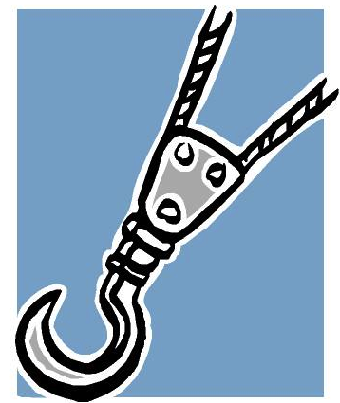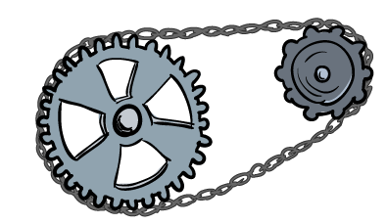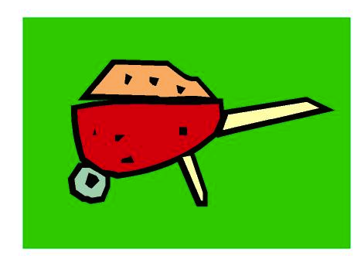
___________________ _____________________ _____________________
- A ________________________ is a device with moving ______________ that _________________ together to ___________________________ a __________________.
  - A ___________________________ is a good example.
- The _________________ includes everything _________________ __________ to make the _____________________ accomplish a ____________, like ________________________ on the bicycle ______________________.
- The _______________________ is what the _______________________ does for ______________, like going fast or _________________________ a steep hill.
- A ____________________ _______________________ is an __________________________ mechanical _________________, such as a ___________________.
- Machines _____________________ ____________________.
- _________________________ ________________________ is the ratio of __________________ force to ____________________ force.
- MA = ___________________________________ ÷ ___________________________________
- ______________________ are useful because you can arrange the _____________________ and the _________________ __________ and _________________ _________ to adjust the ______________________ _____________________ of the lever
Mechanical Advantage of lever = _____________________________÷______________________________
- A ______________ is a simple machine that allows you to _____________ a heavy object with ______________ force than you would need to lift it ________________ up.
The mechanical advantage of ramp = ____________________________ ÷_________________________
Practice
- If the handle of a crowbar is 40 centimeters and the foot is 2 centimeters, what is its mechanical advantage?

- A construction worker uses a board and log as a lever to lift a heavy rock. If the input arm is 3 meters long and the output arm is 0.754 meters long, what is the mechanical advantage of the lever?

- A 500-newton cart is lifted to a height of 1 meter using a 10-meter long ramp. You can see that a worker only has to use 50 newtons of force to pull the cart.

- A lever used to lift a heavy box has an input arm of 4 meters and an output arm of 0.8 meters. What is the MA of the lever?

- What is the mechanical advantage of a lever that has an input arm of 3 meters and an output arm of 2m?

- A rake is held so that its input arm is 0.4 meters and its output arm is 1.0 meter. What is the mechanical advantage of the rake?

- A 5-meter ramp lifts objects to a height of 0.75 meters. What is the mechanical advantage of the ramp?

- A child makes a ramp to push his toy dump truck up to his sandbox. If he uses 5 newtons of force to push the 12-newton truck up the ramp, what is the MA of the ramp?

- A ramp with a MA of 6 is used to move a 36-newton load. What input force is need to push the load up the ramp?

- A mover uses a ramp to pull a 1000-newton cart up to the floor of his truck (0.8 meters high). If it takes a force of 200 newtons to pull the cart, what is the length of the ramp?

