Name____________________________________________ Hr __________
Natural Frequency and Resonance
Do Now: Describe or draw the differences between reflection and refraction.

Frequency Review
Frequency is:
- Measure of _____ ________ a wave goes _____ and ________
- Measured in _________ (Hz);
- One Hertz is one _________ per _________

What is the frequency of this wave? (Time from point A to F is 2 seconds.) From point A to F is ______ ____________. At F the _________ begins to repeat its form. _____________ is number of cycles (wavelengths) per one second. For this wave, one wavelength takes ____ seconds so:
f=1cycle/2 sec. = _________ Hz
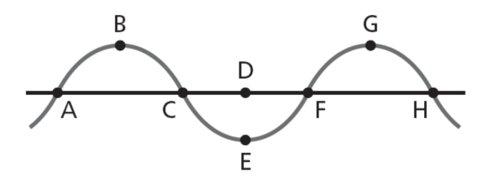

Natural Frequency
Most objects ___________ when hit, struck, plucked, strummed, or somehow __________. If you drop a meter stick or pencil on the floor, it will begin to ___________. If you pluck a guitar string, it will begin to ___________. If you blow air over the top of a pop bottle, the _______ inside will vibrate.
http://www.videobash.com/video_show/high-speed-camera-guitar-strings-28853
When an object vibrates, it tends to ___________ at a particular ____________. The ________________ at which an object tends to vibrate when disturbed is the _____________ _____________ of the object.

The _____________ at which an object will _________ is determined by a variety of factors. Each of these factors will affect the _________________ or the ___________ of the object. Since
frequency = ____________/ ________________,
a change in __________ or ____________ will change the __________ ____________.
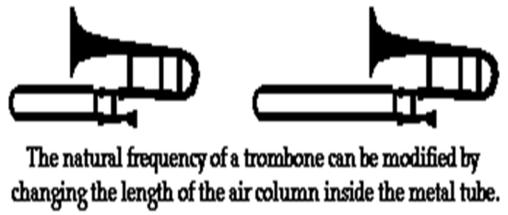

The vibrating portion of a particular string can be shortened by pressing the string against one of the frets on the neck of the guitar. This modification in the length of the string would affect the ________________ of the wave and in turn the ___________ ______________ at which a particular string vibrates.

https://video.search.yahoo.com/video/play;_ylt=A2KLqILANCZTmg4AHrD7w8QF;_ylu=X3oDMTEwb25mNWVtBHNlYwNzcgRzbGsDdmlkBHZ0aWQDVjE1MgRncG9zAzEz?p=playing+chords+on+a+guitar&vid=a485c337de3c8f5fd2167c6d3cb711b4&l=1%3A37&turl=http%3A%2F%2Fts4.mm.bing.net%2Fth%3Fid%3DVN.608046023479526239%26pid%3D15.1&rurl=http%3A%2F%2Fwww.youtube.com%2Fwatch%3Fv%3DBEeh4T03aoo&tit=Bass+Guitar+%3A+Learn+to+Play+Chords+on+the+Bass+Guitar&c=12&sigr=11a523s0q&sigt=11li9v73g&pstcat=arts+culture+and+entertainment&age=0&&tt=b

____________ ______________ are important to know to:
-to determine _______ an object will vibrate
-to know __________ ___________ of wave an object will make if disturbed
-to make an object _____________ a specific kind of ________

Products in which this is important include:
Microwave ovens, ________ _________, musical instruments, _________, buildings, cars and trucks
Resonance: _______________ happens when an object is vibrated by an _________ ________ at its _________ frequency.
Both tuning forks below have the same ___________ ____________. The sound wave from the tuning fork on the left is causing the tuning fork on the right to _________ even though the tuning fork on the right is not being stuck.

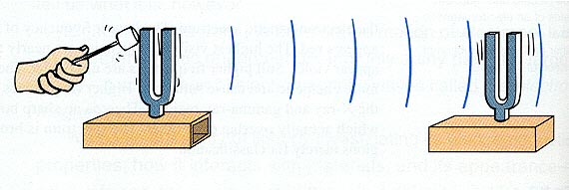
________________ is an important way to ___________ _________ into waves. It is used in microwave ovens, musical instruments, and lasers.

Resonance can also be ______________ if a structure is designed to have a ___________ ____________ close to that of its surroundings.
Take a look at the example of a bridge built in Tacoma, Washington in 1940.

http://www.youtube.com/watch?v=3mclp9QmCGs

