Name _________________________________________ Hr _______
Net Forces, Equilibrium, and Free Body Diagrams Practice
1. Question: Which diagram represents a box in equilibrium? _______
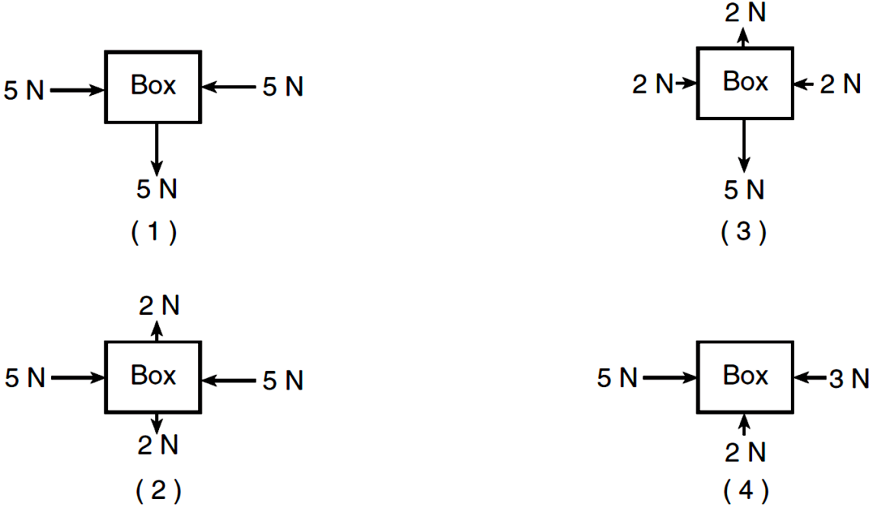
2. Free-body diagrams for four situations are shown below. For each situation, determine the net force acting upon the object. Show your work.

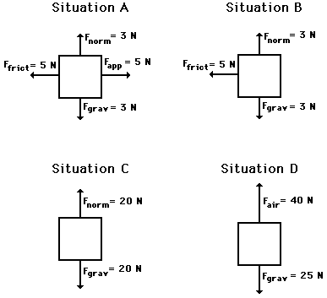
Situation A:
Situation B:
Situation C:
Situation D:

