Name: _____________________________________ Hour: ____________ Date: ______________________
Parts of a Wave
Do Now: Provide 3 examples of how you encounter waves throughout the day. Give the example and what type of wave it is
1.
2.
3.

Crest: ________________________________________________________________________________
Trough: _______________________________________________________________________________
Node: _________________________________________________________________________________
Amplitude: _____________________________________________________________________________
_____________________________________________________
Wavelength: _____________________________________________________________________________
___________________________________________________________________________
Frequency: Measure of ___________________________ a wave goes ________ and ______________
- Measured in ______________________________
- A frequency of 1 hertz describes a wave that goes through ________________________________ (or 1 oscillation) every ______________________
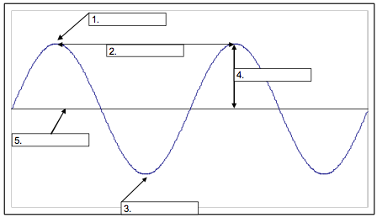
As frequency ______________________, wavelength _______________________________
Activity: Make your own wave
1.You will need:
- Piece of construction paper
- 2 pipe cleaners
- Markers
- Ruler
- Glue or Tape
2.Make a wave out of pipe cleaners using one as the line of origin
- Tape or glue to paper
3.Label the following parts:
- Crest
- Trough
- Wavelength
- Amplitude
4.Measure the length of wavelength and amplitude of your pipe cleaner wave
- Include measurements on your diagram

