Name: __________________________________ Hour: ________________ Date: ____________
Potential and Kinetic Energy
Do Now: List as many types of energy as you can remember/ think of.

Notes:
- Energy: ________________________________________________________
  - Unit: ____________________________
  - Energy can ___________________________________
- Mechanical energy is the energy possessed by an object due to its _____________________ or its ____________________________.
Mechanical energy = Potential Energy + Kinetic Energy
- 2 types of mechanical energy
  - ____________________________________
  - ____________________________________
- Potential Energy:
- Objects with _______________ energy are able to exert forces (exchange energy) as they change ________________.
- _________________ ____________ is energy due to ____________.
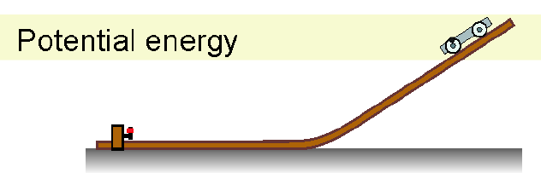
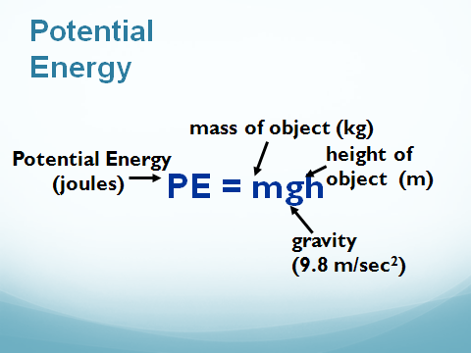

  - The person has _______________ potential energy at the ______________ of the stairs than at the bottom.
  - If we dropped an egg from the 2nd floor and the 3rd floor, which would have more potential energy? ___________________________________

- Example Problems:
  - If your egg has a mass of 2 kg, how much potential energy does it hold at a height of 10 meters?

  - A rock weighs 1000 N. What is its potential energy if it located on a shelf that has a height of 5 meters?

- Kinetic Energy: ________________________________________
  - Depends on: _____________________, ______________________
  - Energy of motion is called ______________energy.
  - A moving cart has kinetic energy because it can hit another object and do _______.
  - 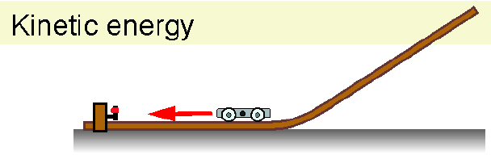
  - Which has more kinetic energy, the regular car at 40 mph or the race car at 120 mph?
______________________________________________________________________
  - Which would hurt more, getting hit by a 15 foot wave or a 2 foot wave?
______________________________________________________________________
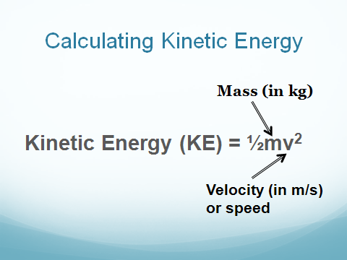

- Example:
  - The bird has a mass of 2 kg. It is flying at a speed of 5 m/s. Find its kinetic energy.

- Mechanical Energy
The total amount of energy of an object due to its ____________ or its stored energy of
____________.
- Mechanical energy = _______ + _______

Practice Problems:
- Write either “potential energy” or “kinetic energy” under the following pictures. Explain why you chose your answer.
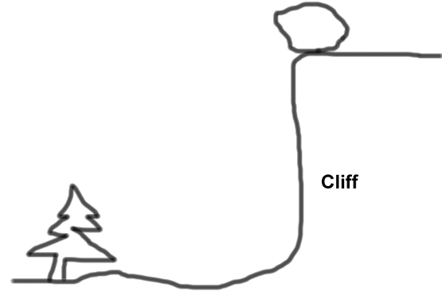
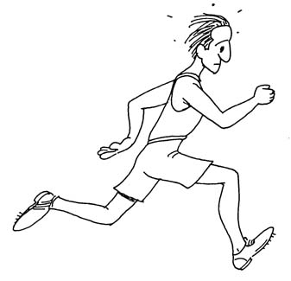
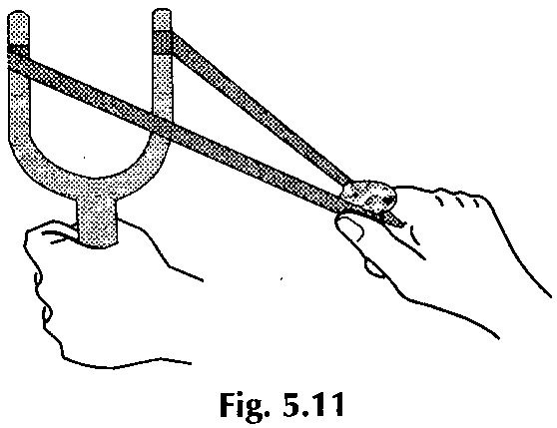

- Identify the energy in each statement as kinetic OR potential.
  - ____________________ A mouse running away from a cat.
  - ____________________ A car driving down Route 82.
  - ____________________ A bowling ball rolling down the lane.
- Determine the amount of potential energy of a 5.0 N- book that is moved to three different shelves on a bookcase. The height of each shelf is 1.0m, 1.5m, and 2.0m.
  - Potential energy at 1.0 m _________________________
  - Potential energy at 1.5 m _________________________
  - Potential energy at 2.0 m _________________________

- A 1.0 kg ball is thrown into the air with an initial velocity of 30 m/s.
  - How much kinetic energy does the ball have?

  - How much potential energy does the ball have when it reaches the top of its ascent?

- You are on skates at the top of a small hill. The height of the hill is 1.7 meters. The last time you checked, your mass was 60.kg.
  - What is your weight in Newtons?

  - What is your potential energy at the top of the hill?

- What is the kinetic energy of a 2,000-kg bat moving at 5.0 m/s?

- A man with a mass of 80 kg is standing on the edge of a table 1.5 m above the ground. What is the man’s potential energy?

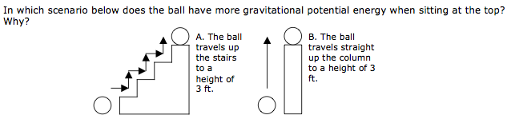

- A 70-kg man is walking at a speed of 2.0 m/s. What is his kinetic energy?

- A 1-kg rock is at a height of 100 meters.
  - What is the rock’s gravitational potential energy at 100 meters high?

  - Calculate the rock’s gravitational potential energy at 50 m, 20 m, 1m, 0 m high. Put the answers in the data table below.

Height (m) | Potential energy (J)

  - Make a graph of height versus energy.

