Name_____________________________________________ Hr___________

**Plate Tectonics-Notes and Practice**

* The _________ of _________ ______________ explains the movement of continents and other geological events like ________________ and _____________.
* The term _______________means ______________ or _______________.
* The theory of plate tectonics, stated in 1965, refers to the _________________ of giant pieces of solid rock on Earth’s surface called _____________ _______________.

**Continental Drift**

In 1915, _____________ ____________ (1880-1930), a German meteorologist, wrote a book titled *The Origin of Continents and Oceans*.

* Wegener gathered evidence that supported his idea that ____the _____________ _______ __________ ____________ _________________.

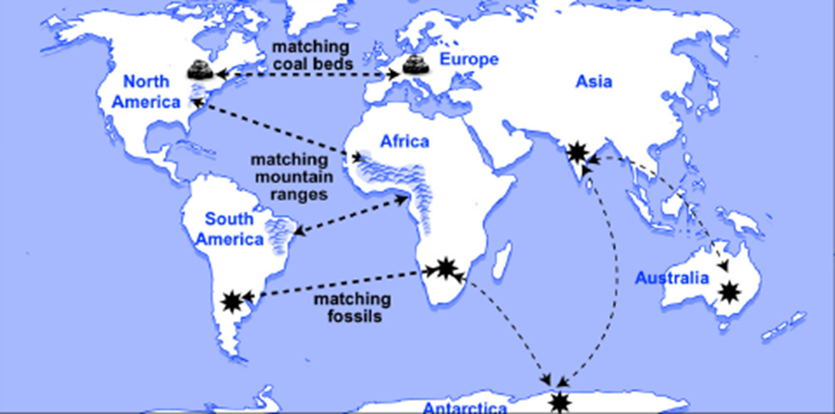

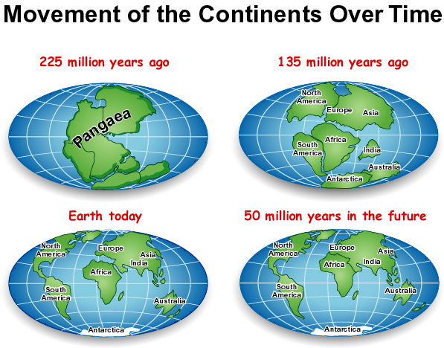

**Sea Floor Spreading**

In the early 1960s, ________ _________ (1906-69), a geologist and former commander of a Navy ship equipped with an echo sounder, used the profile of the sea floor to propose that it was ______________ at the __________________ ___________.

* Around the same time, Robert Dietz (1914-95), a scientist with similar ideas, coined the term _________ _________. Sea-floor spreading describes the _______ _________ on either side of a mid-ocean ridge as _______ ________from the ________ & creating a ______ or _____.
* Hot fluid from the _________ (called __________) enters the rise or valley and _______, creating new sea floor (also called ___________ __________).



**Magnetic Patterns**

* Over geologic time, the _____________ ____________ of Earth has switched.
* Scientists believe the poles switch because of a __________ _____________ between the planet’s _________ and _________ _________.
* In the 1950s and 1960s, scientists discovered that the rocks of the sea floor have a very interesting ______________ ____________.
* Stripes of rock with a _____________ _____________ (normal) ____________ with stripes of rock with a ____________ _______________ (reversed).

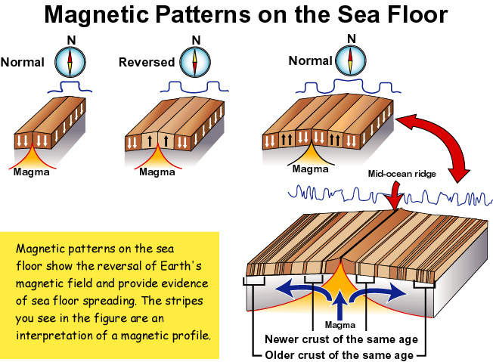

**Describing Plate Boundaries**

* There are _________ main kinds of __________ ______________:

**-Divergent** **-Convergent** 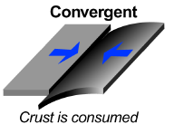OR **-Transform** 

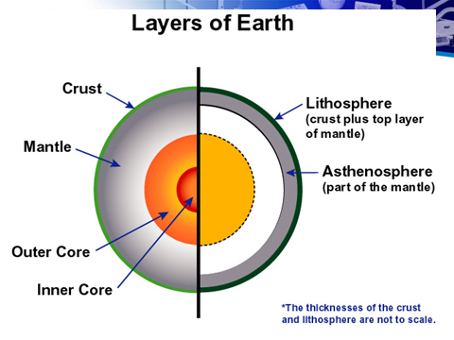

**Plate Tectonics**

* The ______________ ___________ that cover Earth’s surface are pieces of the _____________ that fit together and float on the ____________ (a part of the mantle).
* There are a number of __________ _______________ __________ on Earth’s surface, and smaller plates are being identified all the time.

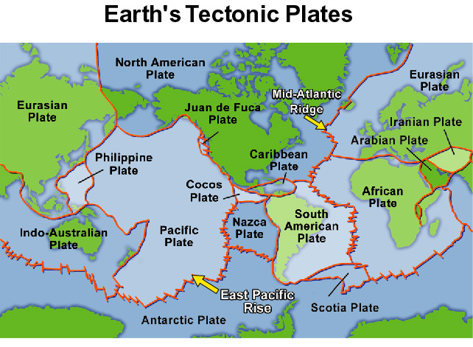

**Divergent Plate Boundaries**

Diverging plates __________ ___________ and new crust forms.

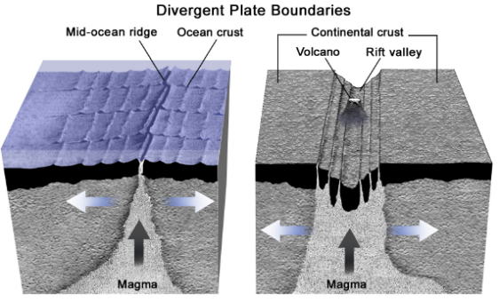

* _____________ boundaries are sites of ____________ and ______________ activity.
* _________ ________ and associated ______ _________ occur at *divergent plate boundaries*.
* In effect, a mid-ocean ridge is like a very long ____________.

**Convergent Plate Boundaries**

Convergent plate boundaries occur where _________ ___________ __________ each other.

* One result of two plates converging is _______________.
* A deep _____________ ___________ marks the boundary between a _____________ and an overriding plate at a ______________ boundary.

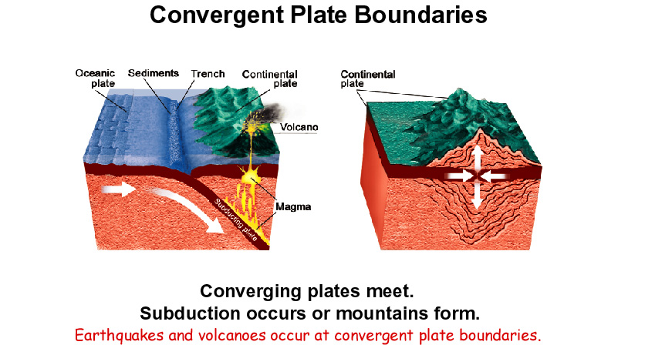

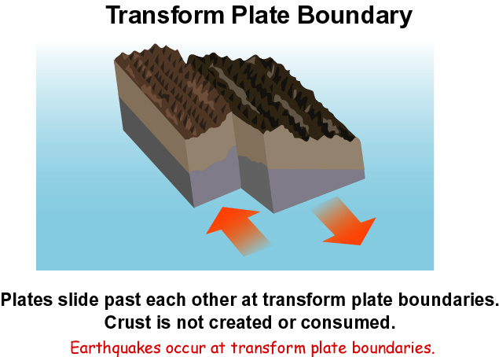

**Movement of Plates**

The movement of tectonic plates is related to the distribution of ______ by ___________ _______________ currents in the __________.



**Practice:**

1.List three pieces of evidence that Wegener used to support his idea that all the continents were joined into one in the past.

2. How does the change in the earth’s magnetic polarity support the idea of sea floor spreading?

3. What are the 3 main types of plate boundaries?

4. What is the main source of energy that causes the tectonic plates to move?