Name: _________________________________________ Hour: ___________ Date:________________
Notes: Rocks and Minerals
Notes:
Groups of Rocks –
- There are _________________ groups of rocks that are formed by the processes in the Earth’s crust.
  - ___________________________ rock forms from the _______________________ and crystallizing of __________________ or lava.
  - _____________________________ rock is made of sediments.
  - _____________________________ rock that is formed from another rock because of ________________ and _______________________.
- Igneous rocks begin to form when rock __________________ in Earth’s mantle.
  - Decreased pressure and the addition of _________________ lower the ________________ temperature of mantle rock so that it melts.
  - As the rock cools, the minerals in the rock ______________________________ and grow.
  - ______________________________ is the process by which crystals form and grow in size.
  - The quicker it cools – the ___________________ crystals form.
  - An igneous rock that forms _____________________ Earth’s surface is called an _______________________________________________.
  - An igneous rock that forms ______________________ Earth’s crust is called an ____________________________________________.
  - __________________________ is an extrusive igneous rock
  - __________________________ is an intrusive igneous rock
- Igneous Rocks are formed when ________ or ____________ solidifies.
- These rocks can become other kinds of rocks when they are ____________ down then ___________ together with other sediment, or changed by ___________ and ________________.
- Sedimentary rocks are formed from ____________________________________________________.
  - Sedimentary rocks are the _______________________________rock found on Earth’s surface.
  - Forming Sedimentary Rock:
    - Sediment: __________________________________________________
    - Compaction: ________________________________________________
    - Cementation: ________________________________________________
  - Sedimentary rocks are identified by the ____________ of the particles that form them.
    - Mudstone _______________________________________________
    - Sandstone _________________________________________________
    - Conglomerate ______________________________________________
  - Most fossils are found in _________________________________________ layers.
    - ______________________________ is a sedimentary rock made mostly of fossils
- A Metamorphic Rock is a rock formed from another kind of rock due to ___________ & ____________.
  - _____________________________________ means to change the form of something.
  - When magma comes in contact with another type of rock, the high heat may form ____________________________ rock near the point of ________________________.
  - This is called ______________________________________________________.
  - During contact metamorphism limestone becomes ____________________ under heat & pressure.
  - _____________________________ metamorphism involves high ___________________ and either low or high temperatures.
  - In this process, the minerals in a rock change to form _____________________________.
  - Heat and pressure result when colliding continents form ___________________________ at a _____________________________________________________.
  - _________________________________ are where we find metamorphic rocks.
- The Rock Cycle
  - There are many processes that keep rocks moving through a cycle:
    - Weathering, __________________________, compaction and cementation, ____________________________, melting and ___________________________.

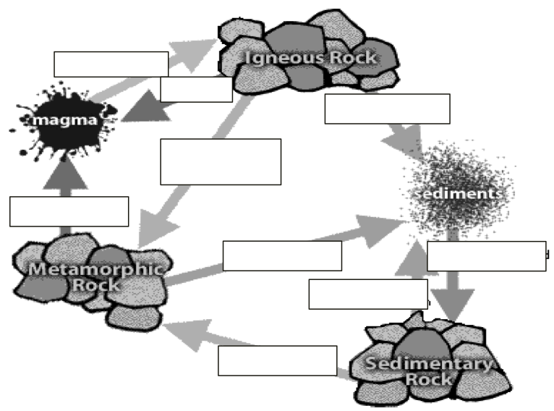

Practice:
- What is a mineral? Are all minerals rocks?

- Name and define the three main types of rock.

- Describe the difference between an extrusive igneous rock and an intrusive igneous rock.

- What is weathering? What does weathering have to do with the formation of sedimentary rock?

- How are sedimentary rocks named? What are the categories sedimentary rocks are described as?

- Change the following statement from a false statement to a true one: Fossils are found in igneous rock.

- How is a metamorphic rock formed? What are two examples of metamorphic rock?

- Explain how the principle of superposition is used by geologists to compare the ages of rocks.

- Determine the type of rock that will form in each of the following scenarios:
  - Lava pours onto the ocean floor and cools

  - Minerals cement small pieces of sand together

  - Mudstone is subjected to great heat and pressure over a long period of time

- On a separate, blank sheet of paper draw and describe the rock cycle to show how rocks change and what factors cause these changes. Should resemble the diagram shown in the text.

Reading Skills: Read the passage below. Then, answer the questions.
Igneous and Sedimentary Rock
Scientists think that Earth began as a melted mixture of many different materials. These materials underwent a physical change as they cooled and solidified. These became the first igneous rocks. Igneous rock continues to form today. Liquid rock changes from a liquid to a solid, when lava that is brought to Earth’s surface by volcanoes hardens. This process can also take place far more slowly, when magma deep beneath the Earth’s surface changes to a solid.
At the same time that new rocks are forming, old rocks are broken down by other processes. Weathering is the process by which wind, water and gravity break up rock. During erosion, broken up pieces of rock are carried by water, wind or ice and deposited as sediments elsewhere. These pieces pile up and, under heat and pressure, form sedimentary rock – rock composed of cemented fragments of older rocks.
- Which of the following statements about the texture of sedimentary rock is most likely true.
  - Sedimentary rocks are always lumpy and made up of large pieces of older rocks
  - Sedimentary rocks all contain alternating bands of lumpy and smooth textures
  - Sedimentary rocks are always smooth and made up of small pieces of older rocks
  - Sedimentary rocks have a variety of textures that depend on the size and type of pieces that make up the rock

- Which of the following statements can be inferred from the information in the passage?
  - Igneous rocks are the hardest form of rock
  - Sedimentary rocks are the final stage in the life cycle of a rock
  - Igneous rocks began forming early in Earth’s history
  - Sedimentary rocks are not affected by weathering

- Is igneous rock or sedimentary rock more likely to contain fossils? Explain your answer.

