Name ____________________________________________ Hr ________ Date_____________

**Volcanoes Notes and Practice**

**Learning Intentions**

* Learn about the role of plate tectonics in causing volcanoes and learn what causes eruptions to be gentle or highly explosive.
* Identify the main types of volcanoes: shield volcanoes, stratovolcanoes, and cinder cones.
* Learn about other forms of volcanic activity such as geysers, hot springs, hydrothermal vents, and geothermal energy.

**VOLCANOES**

______________are places where _____________ (melted) rock and other materials from the earth’s __________ are released. ___________ rock below the earth’s surface is called _________. Below ground, magma forms pools called _________ _______________.

Magma reaches the earth’s surface through pathways called __________. Areas where magma reaches the earth’s surface are called _______. Molten rock that reaches the earth’s __________ and erupts or flows out of a volcano is called _______.

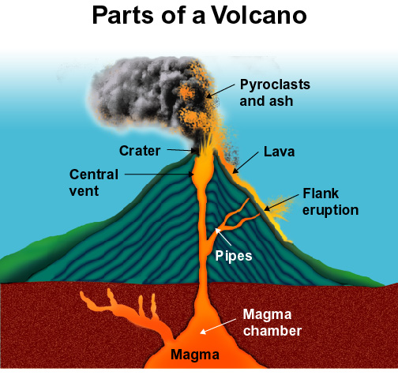 

Volcanoes also release ________ and ________ _____________ into the air. Rock fragments are called ______________, dust particle size fragments are called ________.

A _________is a depression formed at the top of a _____________ mountain after an eruption. Later a lake may form in the _________.

* The eruption of _________ _____ __________ in 1980 reduced the height of this mountain from 2,932 meters (9,677 feet) to 2,535 meters (8,364 feet).
* Early in the morning of May 18, 1980, an _____________ triggered a landslide that caused the bulge to eject magma, water, and gases.



* Solid rock melts and becomes __________under certain conditions that lower the melting point of the material.
* At _______________ _________, water is the key for solid rock to melt and become _______.
* Like _______________, most volcanic activity is found at the _________ of ___________ _________, namely at _____________and ________________ *plate boundaries,* but _______ _______ occur at _____________ plate boundaries.

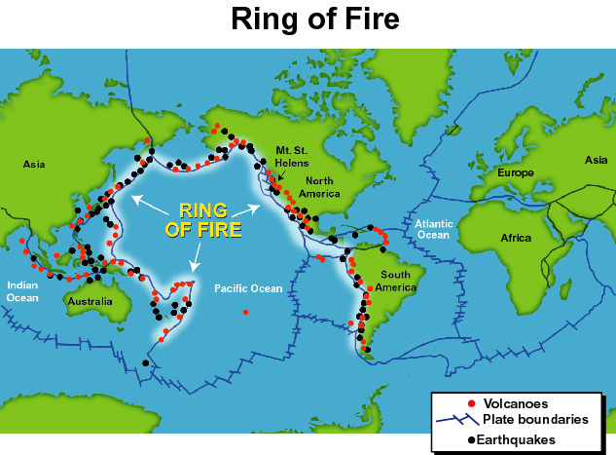

There are three main types of volcanoes:

1- _________ Volcanoes

2- __________________ (also called ______________ _______________)

3- ____________ ___________ Volcanoes

They have different _____________ and are formed from different types of material: lava, pyroclasts, ash, and gases. The ________________, or thickness, of the lava flowing from the volcano is the most important factor in determining the ___________ of the volcano.

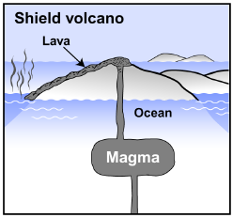

* ________ _____________, fast-flowing ________ is associated with shield volcanoes.
* Because this lava easily flows down hill, shield volcanoes are ______ ________ & ___________.

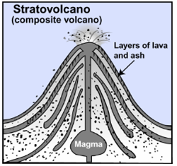_________ _____________ lava is associated with ___________(also called composite volcanoes). These volcanoes range in height from 500 to 10,000 meters.

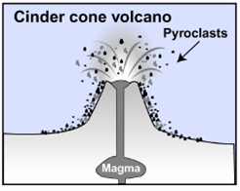

* ________ _______ volcanoes are steep stacks of loose __________ (clumps & particles of lava).
* ____________ _________ are rarely higher than 300 meters.
* Lava viscosity also determines how _____________ an eruption will be.
* Explosive eruptions occur when the lava has a lot of ____________ and ___________ gases.
* Gentle eruptions are associated with _________________ lava from oceanic crust.



Volcanoes also form when an ____________ __________ slides under another oceanic plate.

**Hydrothermal Vents**



_____________ ________ are deep sea, chimney-like structures that occur along mid-ocean ridges.

Some ___________ are also associated with volcanic activity. For example, __________ form at high temperatures deep underground when carbon crystallizes inside rocks called ____________.

* _______________ ____________ is a useful product of volcanic activity.
* When steam from _________collects below ground, it can be tapped just like water in a well.
* The pressurized steam can be used to generate ___________.

**Practice: Match the vocabulary word to its definition.**

1. magma __________ a. The pattern of volcanoes & earthquakes that occurs at the

boundaries of the Pacific Ocean.

2. lava ____________ b. a measure of a material’s resistance to flow

3. Ring of Fire _______ c. A bowl-shaped depression at the top of a volcano

4. magma chamber _______ d. Molten material from the mantle that reaches the earth

surface

5. crater ________ e. Molten material that originates in the mantle

6. Viscosity __________ f. A place where magma collects underground

7. Explain the difference between magma and lava. ____________________________________

8. Describe the differences between the three main types of volcanoes.