Name: ________________________________________ Hour: _____________ Date: 2/20/2013

**\*\*\*\*\*\*\*\*\*\*\*\*\*\*\*\*\*\*\*\*\*\*\*\*\*\*\*\*\*\*\*\*\*\*\*\*\*\*DO NOW\*\*\*\*\*\*\*\*\*\*\*\*\*\*\*\*\*\*\*\*\*\*\*\*\*\*\*\*\*\*\*\*\*\*\*\*\*\*\***

**Word Bank:**

Ear Canal Pinna Stirrup

Hammer Cochlea Outer Ear

Inner Ear Anvil Semi-circular canals

Auditory Nerve Middle Ear

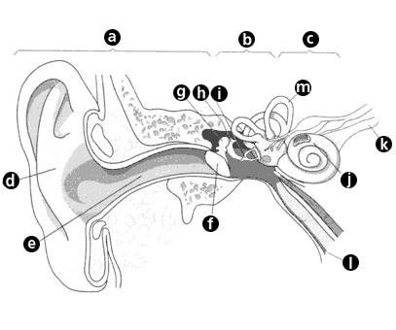

A= _____________________________________

B= _____________________________________

C= _____________________________________

D= _____________________________________

E= _____________________________________

F= _____________________________________

G= _____________________________________

H= _____________________________________ J= _____________________________________

I= _____________________________________ K= ____________________________________

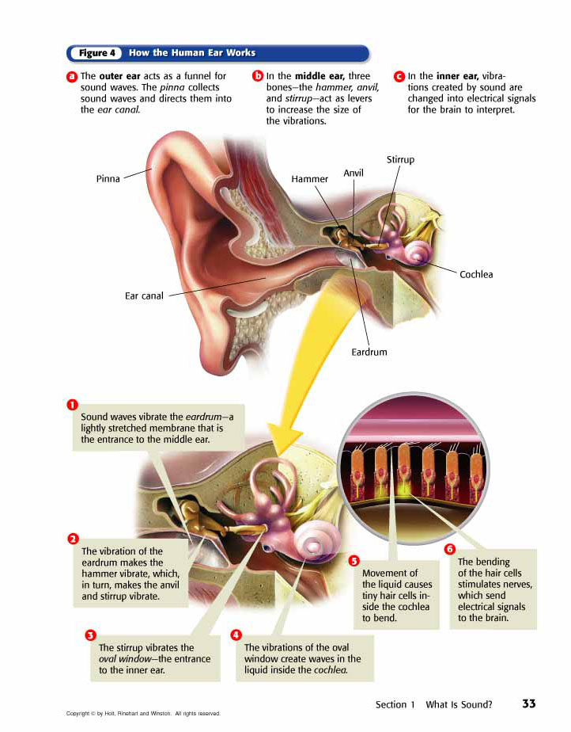

**Questions:**

What part of the ear is the eardrum in? _______________________________

There is liquid inside what pat of the inner ear? _______________________________

What does the bending of the tiny hairs cause? _______________________________

**Hearing Loss or Deafness**

If _________________________ of the ear is ____________________ or does not work correctly, _______________________________ or ______________________ may occur

_________________________ is a common form of hearing loss

1.Happens after a ___________________________________ to _____________

sounds

2.The sounds ___________________ the ____________ in the cochlea, which ________________________ grow back

3.__________________________hearing loss results

________________ exposure to_________________ loud sounds can cause ___________________

___________________ sounds over a _______________ period of time can cause damage

* Wear _______________________ when by loud sound
* _____________________ your headphone ________________!

**Activity:**

Auditory Acuity – How well can you hear?

* With a partner, have one person close their eyes
* The other person stands close to & in front of the first person and *gently* shakes a jingle bell.
* Slowly move away from the person until they say they can no longer hear the jingle bell.
* Record the distance at which the partner stops hearing the bell.
* Repeat this procedure having the person close their right ear. Repeat again with their left ear closed.
* Switch places and repeat for the other partner

|  |  |  |  |
| --- | --- | --- | --- |
| Group Member Name | Distance for both ears | Distance when right ear closed | Distance when left ear closed |
|  |  |  |  |
|  |  |  |  |
|  |  |  |  |
|  |  |  |  |

**Sound Localization: Are two ears better than one?**

* Have one person stand on the X on the floor and close their eyes
* Another group member should stand on one of the lines that are 5, 10 or 15ft from the X and say the name of the group member on the X
* The person on the X must guess if the person is on the 5, 10 or 15 ft line.
* Repeat this procedure having the person close their left ear
* Repeat this procedure having the person close their right ear
* Let each group member take a turn
* Record the results in the table below by putting a check in every box when the individual guessed the distance correctly

|  |  |  |  |  |  |  |  |  |  |
| --- | --- | --- | --- | --- | --- | --- | --- | --- | --- |
| **Group Member Name** | **Both Ears** | | | **Left Ear Closed** | | | **Right Ear Closed** | | |
| 5 ft | 10 ft | 15 ft | 5 ft | 10 ft | 15 ft | 5 ft | 10 ft | 15 ft |
| EXAMPLE | √ | √ | √ | √ |  |  | √ |  |  |
|  |  |  |  |  |  |  |  |  |  |
|  |  |  |  |  |  |  |  |  |  |
|  |  |  |  |  |  |  |  |  |  |

****Example – the example participant guessed the 5, 10 and 15ft distance with both ears open,

but only the 5 ft distance when the left or right ear was close.

**Analysis Questions:**

1. Could you hear the jingle bell sound further when using one ear in particular or using both ears? ___________________________________________________________________
2. Could you hear the jingle bell further away using your left ear or right ear? ________________ _________________________________________________________________________
3. How do the distances compare between you and your partner? _______________ _________________________________________________________________________
4. Do you think it would be easier or harder to detect the sound if your partner stood at an angle and not straight in front of you? ___________________________________________ _________________________________________________________________________
5. Are two ears better for detecting sound or one? Explain your reasoning. _______________ __________________________________________________________________________________________________________________________________________________

**Name: _______________________________________ Hour: __________ Date: ____________**

**Word Bank:**

Ossicles Pinna Stapes Ear Drum

Malleus Cochlea Outter Ear

Inner Ear Incus Semi-circular canals

Auditory Nerve Middle Ear Ear Canal

1. I have nothing to do with hearing. It helps us balance! What part am I? ________________________________________
2. If you translate me from Latin, I mean “anvil.” I am the second of the tiny ossicles. What part am I? ________________________________________
3. I take vibrations and turn them into nerve signals. What part am I? ________________________________________
4. I have the pinna, ear canal, and ear drum as part of me. What am I? ________________________________________
5. I have to catch all of the sounds in the world around you and bring them in to the rest of the ear. What part am I? ________________________________________
6. We are made of bone and vibrate in order to pass sounds through the middle ear. What part am I? ________________________________________
7. If you translate my name from Latin to English, I mean “hammer.” I am the first of the tiny bones. What part am I? ________________________________________
8. I make ear wax, which you think is gross, but really keeps dirt and bacteria out of the rest of your ear. What part am I? ________________________________________
9. I have the tiny ossicles and semi-circular canals as part of me. What am I? ________________________________________
10. I carry the nerve signals to the brain. What part am I? ________________________________________
11. I am the third of the tiny ossicles. My name means “stirrup” in Latin. What part am I? ________________________________________

12. I have the cochlea and beginning of the auditory nerve as part of me. What am I?

________________________________________

# Your Ears

Did you hear something? Maybe the sound you heard was as quiet as your cat licking her paws. Or maybe it was loud, like a siren going by. Sounds are everywhere, and you have two cool parts on your body that let you hear them all: your ears!

Your ears are in charge of collecting sounds, processing them, and sending sound signals to your brain. And that's not all — your ears also help you keep your balance. So if you bend over to pick up your cat, who is making all that noise, you won’t fall down.

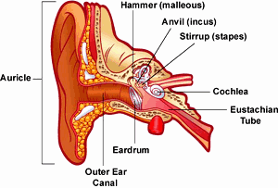 The ear is made up of three different sections: the outer ear, the middle ear, and the inner ear. These parts all work together so you can hear and process sounds.

**The Outer Ear: Catch the Wave**

The outer ear is called the **pinna** or auricle (say: **or**-ih-kul). This is the part of the ear that people can see. It's what people pierce to wear earrings and what your friend whispers into when it's time for a secret. The main job of the outer ear is to collect sounds, whether they're your friend's whispers or a barking dog.

The outer ear also includes the **ear canal**, where wax is produced. Earwax is that gunky stuff that protects the canal. Earwax contains chemicals that fight off infections that could hurt the skin inside the ear canal. It also collects dirt to help keep the ear canal clean. So earwax isn't just gross. It's gross and useful.

**The Middle Ear: Good Vibrations**

After sound waves enter the outer ear, they travel through the ear canal and make their way to the middle ear. The middle ear's main job is to take those sound waves and turn them into vibrations that are delivered to the inner ear. To do this, it needs the **eardrum**, which is a thin piece of skin stretched tight like a drum.

The eardrum separates the outer ear from the middle ear and the **ossicles** (say: **ah**-sih-kulz). What are ossicles? They are the three tiniest, most delicate bones in your body. They include:

* the **malleus** (say: **mah**-lee-us), which is attached to the eardrum and means "hammer" in Latin
* the **incus** (say: **in**-kus), which is attached to the malleus and means "anvil" in Latin
* the **stapes** (say: **stay**-peez), the smallest bone in the body, which is attached to the incus and means "stirrup" in Latin

When sound waves reach the eardrum, they cause the eardrum to vibrate. When the eardrum vibrates, it moves the tiny ossicles — from the hammer to the anvil and then to the stirrup. These bones help sound move along on its journey into the inner ear.

**The Inner Ear: Nerve Signals Start Here**

Sound comes into the inner ear as vibrations and enters the **cochlea** (say: **ko**-klee-uh), a small, curled tube in the inner ear. The cochlea is filled with liquid, which is set into motion, like a wave, when the ossicles vibrate.

The cochlea is also lined with tiny cells covered in tiny hairs that are so small you would need a microscope to see them. They may be small, but they're awfully important. When sound reaches the cochlea, the vibrations (sound) cause the hairs on the cells to move, creating nerve signals. Those nerve signals travel up the **auditory nerve** to the brain. The brain understands these signals as sounds and hooray! You hear your favorite song on the radio.

**Day or Night, Ears Keep You Upright**

Ears do more than hear. They keep you balanced, too. In the inner ear, there are three small loops above the cochlea called **semicircular canals**. Like the cochlea, they are also filled with liquid and have thousands of microscopic hairs.

When you move your head, the liquid in the semicircular canals moves too. The liquid moves the tiny hairs, which send a nerve message to your brain about the position of your head. In less than a second, your brain sends messages to the right muscles so that you keep your balance. If you’ve ever felt dizzy (or vertigo), it is because that liquid in your semicircular canals kept moving around after your body has stopped. Once the fluid in the semicircular canals stops moving, your brain gets the right message and you regain your balance.

**Three Cheers for the Ears!**

Your ears take care of you, so take care of them. Protect your hearing by wearing earplugs at loud music concerts and around noisy machinery, like in wood or metal shop at school. Keep the volume down on your stereo, especially if you're in the car or wearing headphones. Don't go poking around in your ears, even with cotton swabs. Our ears help take care of us – let’s make sure we are returning the favor!