Name ____________________________________________ Hr ________

**Earthquakes**

**List three pieces of evidence that Wegener used to support his idea that all the continents were joined into one in the past.**

**How does the change in the earth’s magnetic polarity support the idea of sea floor spreading?**

**What is the main source of energy that causes the tectonic plates to move?**

**Earthquakes**

As _____________ __________ move, __________ causes the rocks at _________ ___________ to stretch or compress. Like a stretched rubber band or a compressed spring, these rocks store ________ (_____________l energy).

When the rocks break, change shape, or decrease in volume, the _____________ energy is suddenly converted to _________________ energy and an ________________ occurs.

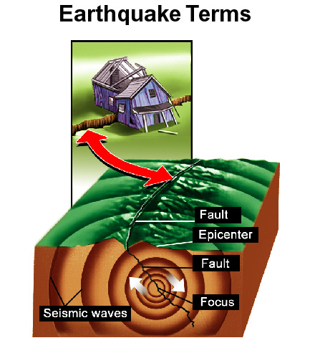

*A _____________________* measures___________________, and seismologists use ___________ waves to study Earth’s internal structure.

This is similar to how a doctor uses _______________ to look at bone structure.

The majority of earthquakes occur at the ________________________ of _______________ ______________. Individual earthquakes also occur where there is a _____________.

A ____________ is a place in Earth’s crust such as a __________ or a ___________*plate boundary*.

 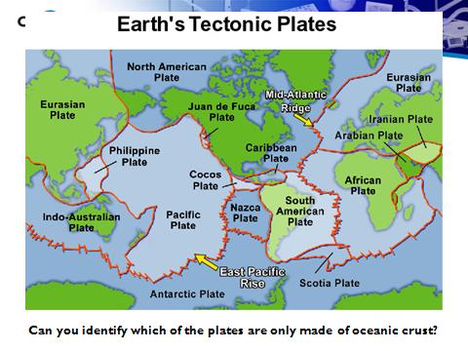

**Earthquakes in the U.S.**

The __________ ___________ of the United States experiences frequent _________________ because those regions are near the _______ ____________ ____________ and a plate boundary. The ________________ and ____________ United States rarely experience ________________.

