Name: _______________________________________ Hour: ________________ Date: ____________________

Work and Power Practice

Do Now: Complete the following table to solve for force, distance, and time.

|  |  |  |
| --- | --- | --- |
| **Solving for** | **Known** | **Equation** |
| Work | Force and Distance | Work = force X distance |
| Force |  |  |
| Distance |  |  |
| Power | Work and time | Power = work ÷ time |
| Work |  |  |
| Time |  |  |

Recall Equations

* Work = _______________________ X ____________________________
* Force = _______________________ ÷ ____________________________
* Distance = _____________________ ÷ ____________________________
* Power = _______________________ ÷ ____________________________
* Work = ________________________X ____________________________
* Time = ________________________ ÷ _____________________________

Review Work:

* Work is the amount _______________________________________________________________________
* Work =_______________________________ X ________________________________
* Unit: ____________________________________

Efficiency:

* Every process that is done by machines can be simplified in terms of work:
* 1.*work input:* ____________________________________________________________________________
* 2.*work output:* ___________________________________________________________________________
* The *efficiency* of a machine is the ratio of usable _______________________ work ____________________ by total ____________________ work.
* Efficiency is usually expressed in __________________________
* Efficiency = --------------------------------- X

Practice Problem: You see a newspaper advertisement for a new, highly efficient machine. The machine claims to produce 2,000 joules of output work for every 2,100 joules of input work. What is the machine’s efficiency?

**Independent Practice:** Complete the following problems on work, power and efficiency.

1. A cell phone charger uses 4.83 joules per second when plugged into an outlet, but only 1.31 joules per second actually goes into the cell phone battery. The remaining joules are lost as heat. That's why the battery feels warm after it has been charging a while. How efficient is the charger?
2. A power station burns 75 kilograms of coal per second. Each kg of coal contains 27 million joules of energy. The power station’s output is 800 million watts. How efficient is this power station?
3. Complete the table below:

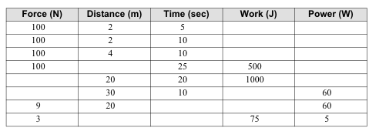

1. Michael weighs 600 newtons. He climbs a flight of stairs that is 3.0 meters tall in 4.0 seconds.
   1. How much work did he do?
   2. What was Oliver’s power in watts?
2. A machine does 1,500 joules of work in 30 seconds. What is the power of this machine?
3. Suppose a force of 100 newtons is used to push an object a distance of 5 meters in 15 seconds. Find the work done and the power for this situation.