Name ____________________________________________________________ Hr ______________
Electromagnetic Radiation Notes
Visible light is an EM wave. Just as we can ___________ only some frequencies of sound, we can only _______ some frequencies of EM waves. There are ______ more types of EM waves which we cannot see.
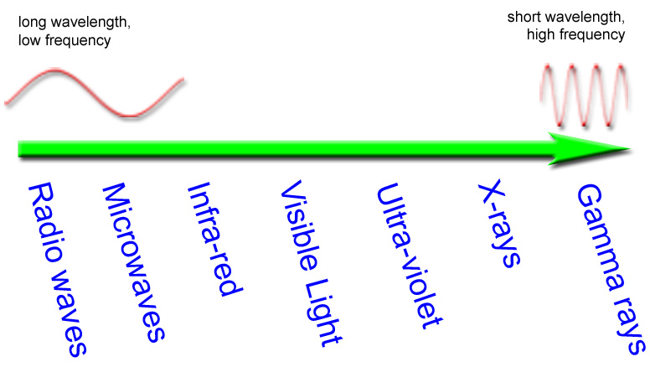
RADIOWAVES
- Wavelength: 1m to ____________________
- Frequency: 3 x 10⁹ to 3 x 10⁴ Hz
- Uses: Telecommunications, TV, Radio
- Dangers: none
- We use __________ ___________ to listen to the radio and watch TV.
- The __________ changes the signal into __________, and the TV changes it into _________.
- Radio waves are stopped easily by _________.
- ___________ ___________ use radio waves to let you connect to the internet without a cable.
- Radio waves travel in ____________ ___________. Part of the atmosphere round the earth can reflect radio waves.
- This means we can send signals over long distances by bouncing the signal off the _______________e.
MICROWAVES
- Wavelength: 0.001m to __________
- Frequency: 3 x 10¹² to 3 x 10⁹ Hz
- Uses: Telecommunications, RADAR, Cooking
- Dangers: can produce burns, clouds eye, cancer (?)
- _______________ _____________ use microwaves to send the phone signal
- Microwaves are used for cooking food. So what happens? Food has _________ inside it. The microwaves make the water in the food _________. The water molecules bang into each other. This makes ____________, which makes heat.
INFRA-RED
- Wavelength: 740nm to 0.01m
- Frequency: 4 x 10¹⁴ to 3 x 10¹¹ Hz
- Uses: Heating, cooking, TV remotes, night-vision
- Dangers: can burn
- We can see infra-red radiation using a __________ camera.
- How is this useful? This is the infra-red radiation. The ____________ can see it, even though your ______ can’t!
VISIBLE LIGHT
- Wavelength: 370nm (violet) to 740nm (red)
- Frequency: 8 x 10¹⁴ to 4 x 10¹⁴ Hz
- Uses: seeing
- Dangers: eye damage from bright lights
- Visible light is best at getting through our ________________ – which is why we use it to see!
- __________ light is made up of different colors. We can see this in a rainbow. The drops of water in the air are splitting the light from the sun into its different colors by ____________.
ULTRAVIOLET
- Wavelength: 10⁻⁹ m to 370nm
- Frequency: 3 x 10¹⁷ to 8 x 10¹⁴ Hz
- Uses: tanning salons, fake money detections, pollination
- Dangers: _________ ____________
Bees see in UV to help them find pollen!
_________________ ______________ comes from the sun. UV can be useful, BUT…ultraviolet light causes sunburn. Skin cells __________ the UV radiation. The _________ of the radiation causes damage to the cell. ___________ travels to the skin to try and fix the damage. This is why skin goes red. How can you protect yourself from sunburn? Ingredients in sun screen __________ and _____________ UV radiation or _________ the radiation and turn it into heat.

X-RAYS
- Wavelength: 10⁻¹² to 10⁻⁷ m
- Frequency: 3 x 10²⁰ to 3 x 10¹⁵ Hz
- Uses: medical imagery, _____________
- Dangers: cancer
- We can use x-rays to look __________ the ____________ instead of cutting it open.
How do x-rays work? When x-rays hit your body, most go straight through you. When an x-ray hits a bone, the bone __________ it so the x-rays do not get to the film. This makes the bone look ________ on the x-ray photograph.
Are x-rays safe? In small doses, yes. Big doses of x-rays can damage your body, causing _________. People who use x-rays have to protect themselves. X-rays can damage ___________ ___________, so pregnant women have to protect themselves too.
GAMMA RAYS
- Wavelength: 10⁻¹⁶ to 10⁻⁹ m
- Frequency: 3 x 10²⁴ to 3 x 10¹⁷ Hz
- Uses: _____________ _________________, observing the universe
- Dangers: cancer
Gamma radiation is the _______________ _______________ type of radiation. It causes ______________ _______________. It can also cause cancer. The more radiation you are exposed to, the more ill you will be.
Is it ever useful? Yes – because it is ______________ to cells, it can be used to kill ___________ cells. This is called __________________. It is important that the gamma radiation hits the cancer without hitting too many of the ________________ cells. To do this, more than one beam of radiation is used. This means that less of the healthy cells are damaged by the radiation.
The Dangers of the EM Spectrum
As the _____________________ ___________________, _______________ gets smaller. Eventually the waves are so small that they can interact with _________, _________, and atoms.
What is the link?
They all travel as electromagnetic waves!

FOR EXTRA CREDIT: Create a mnemonic to remember the order of the EM spectrum and display it on a poster.

