Name _______________________________________________________________ Hr _______

**Conservation of Energy Notes**

**Do Now**

A bow is pulled back so that the arrow has a potential energy of 50 J. What is the kinetic energy of the arrow after it is shot from the bow?

**Review of Energy**

*Energy* is the property of an object or system that allows it to do _______. __________ is measured in Joules (J).

Pushing a 1-kilogram object with a force of one __________ for a distance of one ________ uses one __________ of energy.

**Some Forms of Energy**

*Mechanical energy* is the energy possessed by an object due to its ____________ or its __________.

* *_____________ energy* and ___________ *energy* are both forms of ______________ energy.

**CALCULATING POTENTIAL AND KINETIC ENERGY**

The formula for _______________ Energy is: PE = mgh where:

PE = ____________energy in __________ (J)

m = __________ in kilograms (kg)

g = the acceleration of __________ on earth

(g = 9.8 m/s2)

The formula for _____________ Energy is: KE = ½ mv2 where:

KE = __________ energy in Joules (J)

m = __________ in kilograms (kg)

v = _________ in ________ per second (m/s)

**PROBLEM 1-Calculate Potential Energy**

A 2 kg rock is at the edge of a cliff 20 meters above a lake. It becomes loose and falls toward the water below. Before the rock begins to fall, what is its potential energy?

**Looking for:** _________

**Given:** m =________; h = ________; g = _________

**Relationships:** _____________

**Solution:** PE = 2 kg x 9.8 m/s2 x 20 m PE = 392 J

**PROBLEM 2 - Calculate Kinetic Energy**

Calculate the kinetic energy of a toy car with a mass of 2 kg that is moving at a speed of 2 m/s.

**Looking for:** _________

**Given:** _____________________________

**Relationship:** __________________

**Solution:**

____________________________________________________________________________

**Conservation of Energy**

The idea that ____________ transforms from one form into another without a change in the total amount is called the ***_________ of _______________ of ____________***.

The law of energy conservation says:

- The total energy ___________a change equals the total energy ________ the change.

- Energy cannot be ___________ or _____________. It can be _________________ from one form

into another, but the total amount of ___________ never changes.

**Conservation of Energy in a Pendulum**

A _____________ is a system in which a mass, called a ____, swings back & forth on a string. When the bob is at its highest point, it briefly ________ & all of its energy is PE, _________________ _____________.

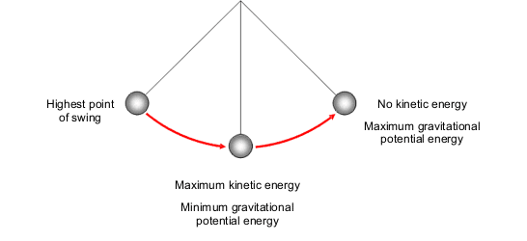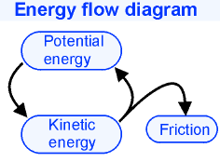

When the bob is at its ______________ point, all its energy is KE, _____________ energy.

At each point in its travel, the sum of its ­­­­­­­___________ & ____________ energy, PE + KE, is the same. The bob continues to travel until its energy is converted into heat by ____________.

**Conservation of Energy in a Tossed Ball**

When you throw a ball in the air, the ball starts with ___________ energy. As the ball rises, some of its kinetic energy is _______________ into ______________ ___________.

At the top of its travel, *where it is momentarily _____________ (v = 0)*, the ball’s energy is all ______________ ___________. As the ball drops from its _________ point, its _____________ energy is ___________ back into ___________ energy.



**Let’s go back to Problem 1 & solve for PE & KE as the rock falls:**

A 2 kg rock is at the edge of a cliff 20 meters above a lake. It becomes loose and falls toward the water below. What is the potential and kinetic energy of the rock at the following positions:

1. Before the rock begins to fall (h= 20 m),

2. When the rock has fallen half way to the ground (h = 10 m),

3. Just before the rock hits the ground (h = 0 m).

**Looking for: ________________________________________________**

**Given: ___________________________________________________**

**Relationships: __________________________________________________________**

**Solution:**  at the top of the cliff, h = 20 m;_____________________________________________

________________________________________________________________________________

Halfway down the cliff, where h = 10 m: _________________________________________________

________________________________________________________________________________

Just before the rock hits the ground, h = 0 m.___________________________________________

*All* of the _______________energy from the top of the cliff has been ___________ into ___________ energy as the rock is about to hit the ground!

**Calculate what happens when the car from Problem 2 rolls up a ramp:**

We calculated the kinetic energy of the toy car with a mass of 2 kg moving at a speed of 2 m/s to be KE = 4 J. If the car rolls up a ramp, how high will it travel before all of its kinetic energy is transformed into potential energy, causing the car to stop?



1. **Looking for:** ____________ 2. **Given:** _____________________________
2. **Relationships:** ___________________
3. **Solution:** ______________________________________________________________

______________________________________________________________________

**PRACTICE:**

1. Calculate the kinetic energy of a toy truck that has a mass of 3kg moving at a

speed of 4 m/s.

2. A mouse and an elephant are running with the same kinetic energy. If KE = ½ mv2,

is the mouse or the elephant running faster? Why?

3. A 90 kg block of ice is lifted to a height of 3 m. What is the potential energy of the ice

block?

4. A falling object has a Potential Energy of 10 J and a Kinetic Energy of 5 J at one point in its fall. A little while later, the object has a Potential Energy of 3 J. What is its Kinetic Energy when the Potential Energy is 3 J?

5. A 500 kg roller coaster is stopped at the top of a track that is 45 m from the ground. What is the potential energy of the roller coaster? What will be the kinetic energy of the roller coaster when it gets to ground level?

6. What is the potential energy of a 3 kg ball lying on the ground?

7. A ball that has a mass of 1 kg, is thrown into the air with a speed of 30 m/s.

a. How much kinetic energy does the ball have immediately after it is thrown?

b. How much potential energy does the ball have when it reaches the highest point in its travel?

c. How high into the air did the ball travel?