Name __________________________________________ Hr _______ Date ____________

**Rocks and Minerals Notes and Practice**

Mon. April 28 Do Now:

* Define constructive and destructive.
* List two constructive and two destructive processes on the earth.

**The composition of rocks**

* A _________is a naturally-formed solid made of one or more _______________.

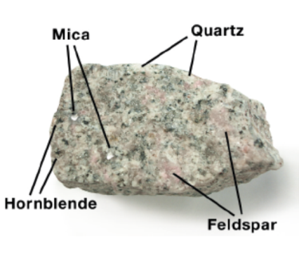

**Rocks are made of _____________**

* A *mineral* is a ___________, _____________ object with a __________chemical composition.
* Minerals have __________ arranged into orderly structures called _____________.

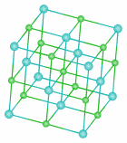 

* ____________and _____________ are both minerals that are made of ___________, but their crystalline structures are different.
* There are more than ________________ minerals on Earth.
* The two most abundant elements in Earth’s crust, are ___________ and _____________.

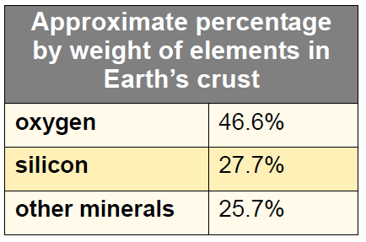

**Common minerals and cleavage planes**

* Mica is a _________ with its minerals stacked like the pages in a book. It has ______ cleavage plain.
* A ___________ ________is a ___________ along which a mineral ___________ _______.

 

* ___________ is the most abundant mineral in Earth’s crust. It has ______ cleavage planes.
* Like feldspar, hornblende has two _____________ ____________.
* The mineral __________ has ____________ directions of cleavage and breaks into _______.



* ______________ is the second most abundant mineral in Earth’s crust.
* Unlike feldspar, quartz ___________ ______________ _____________.
* When quartz breaks, it ______ __________ split along planes.

**Mohs hardness scale**

* *Mohs hardness scale* was developed in 1812 by Friedrick Mohs (an Austrian mineral expert) as a ___________ ___ _______________ ______________.
* This scale uses _____minerals to represent variations in ___________.



**Practice**

1. What are all rocks made of? __________________________

2. How are the atoms of minerals organized? __________________________

3. Give an example of an element that can be formed into different mineral with different crystal structure.

4. What are the two most commonly found minerals in earth’s crust?

5. What is a cleavage plain? ______________________________________________

6. Give an example of a mineral that has one cleavage plane.

7. Give an example of a mineral that has two cleavage planes.

8. Give an example of a mineral that has three cleavage planes.

9. What is the most common mineral in earth’s crust? _________________________

10. What is Moh’s Hardness Scale and how is it used?