Name ___________________________________________ Hr ______

**SPEED VS. TIME GRAPHS-NOTES AND PRACTICE**



**A helicopter’s speed increases from 25 m/s to 60 m/s in a time of 5 seconds. What is the helicopter’s *acceleration*?**

We know that:  
 vstart = vfinish = t =   
  
Use those to calculate acceleration:  
  
a =

**A skateboarder traveling at a speed of 9.0 m/s rolls to a stop at the top of a ramp in a time of 3.0 seconds. What is the acceleration of the skateboarder?**

We know that:

vstart = vfinish = t =   
  
Use those to calculate acceleration:  
  
a =

**A race car accelerates from a velocity of 18 m/s to a finish velocity of 32 m/s in a time of 2 seconds. Calculate the acceleration of the car.**

We know that:

vstart = vfinish = t =   
  
Use those to calculate acceleration:  
  
a =

We have learned to analyze and make ***distance vs. _________*** graphs. We saw that:

* slope = ___________
* steeper slope = ____________ _______________
* Straight line = ___________ ___________
* flat line = __________ ___________
* Single point = ____________________ ___________

**Now we will look at *speed vs. time* graphs.**

* A ____________ vs. time graph is useful for showing how the speed of a moving object changes over ___________.
* If the line on the graph is horizontal, then the car is moving at a ____________ speed. There is no change in speed so there is no change in _________________.
* You can use speed vs. time graphs to determine __________________.
* Remember: The “__________________” of a line is called its _________.

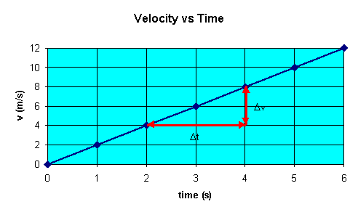

Speed vs. Time

* The slope is equal to the ___________ divided by the _________.
* The slope for speed vs. time graph is therefore ____________ *in __________ divided by time.*
  + Which equals WHAT? __________

Positive _______________________ adds more speed each second.

* + Positive slope: the line slopes _____________; acceleration ________________

Negative acceleration _______________ some speed each second, so things get ___________.

* Negative slope: the line slopes ________________; acceleration _____________

The position vs. time graph also shows acceleration. The graph is a ___________when there is ______________.

**Review of terms:**

* _____________: amount of space between 2 points
* Speed: how quickly something moves over a _________; distance divided by _______
  + Velocity: the same as speed but with a specific __________
  + Acceleration: the rate at which speed or velocity changes; change in _________ divided by _________

**Reading Graphs: *Position* vs. Time**

* x-axis (independent variable): ________
* y-axis (dependent variable): ____________
* Slope = _______________
* Horizontal line: at rest; speed is ________
* Straight line: ___________ speed; speed ______ changing
  + positive slope = moving away from starting point
  + negative slope = moving toward starting point
* Curved line: changing speed (_______________)
  + Speeding up or _____________ down

**Reading Graphs: *Speed* vs. Time**

* x-axis (independent variable): ___________
* y-axis (dependent variable): __________
* Slope = __________________
* Horizontal line = constant speed; ________ acceleration
* Straight line = ____________ acceleration (speed is changing at the same rate every second)
  + positive slope = acceleration _____________
  + negative slope = acceleration decreasing (_____________________)

**Practice: Using a piece of graph paper:**

1. Graph the following speed vs. time data.

Speed (m/s) Time (sec)

0 0

10 2

20 4

30 6

40 8

50 10

2. Graph the following velocity vs. time data:

|  |  |
| --- | --- |
| **Velocity (m/s)** | **Time (s)** |
| 0 | 0 |
| 1.27 | 0.59 |
| 2.13 | 0.87 |
| 2.63 | 1.5 |
| 3 | 2.03 |

3. Graph the following velocity vs. time data:

|  |  |
| --- | --- |
| **Velocity (m/s)** | **Time (s)** |
| 0 | 0 |
| 1.03 | 0.97 |
| 0.94 | 2.03 |
| 0.83 | 3.23 |
| 0.54 | 5.09 |