Name: ____________________________________ Hour: _______________ Date: ____________________
Transverse vs. Longitudinal Waves
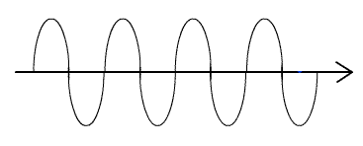

Measure the distance between two crests or two troughs in centimeters (cm). What is this distance?

Measure the distance from the line of origin to a crest or trough in centimeters (cm) . What is this distance?

What do waves do?
Two Broad Types of Waves:
- Mechanical Waves: need _____________________________________________________________
- Electromagnetic Waves can travel through ______________________________________________
Mechanical waves travel through mediums such as:
Mechanical waves can be:
- _____________________________
- _____________________________
Transverse Waves – ________________ moves ______ and __________ or side to side while __________________________ _____________________
- Oscillations _________ in the _____________________ of the ____________________
Longitudinal Waves – _________________ moves along the _____________________ while traveling ________________________
- Oscillations in the ______________ direction the wave ________________
Put the following waves under the correct category:

A wave at a ball game
Guitar string
Slinky
Flag waving in the wind
Sound wave
Shaking a rope
Water wave

Electromagnetic Waves include ____________________________________________________________
Word of the Day: Compression –

